Vol IX Book 03 — Federal Application-Aware Networking — App Registration Governance
  - The app-registration lifecycle as a governed catalog — request, scoped consent, short-lived credentials, rotation, and attestation
SSA Cloud Services Team
2026-07-12 15:00 ET
INTERNAL — NOT FOR PUBLIC DISTRIBUTION

Draft Proposal — Subject to Review
Developed by the CSI Team (Cloud Services Infrastructure); not yet reviewed or approved by the SSA CIO Office, OIS, or leadership. Date Code: 2026-07-12 15:00 ET
Series Context — Volume IX Book 03. App registrations are the machine analogue of the joiner/mover/leaver lifecycle — and the largest source of long-lived-secret and over-consent risk in an Entra estate. The architecture is set (Vol I Book 03 Certificates & Tokens; Vol VI Book 02 Identity & Access as Code); this book adds the governed lifecycle: request, scoped consent, short-lived credentials, automated rotation, and attestation.

What This Document Addresses
An app registration is a workload identity: a service principal with credentials and consented permissions. Left ungoverned, it is where credential sprawl lives — long-lived client secrets pasted into config, over-broad admin consent granted “to make it work,” and orphaned apps whose owner left months ago. Each is a standing violation of least privilege (AC-6) and secure authenticator management (IA-5).
This book governs the whole lifecycle as catalog work, closing IA-5(2), SC-17, and AC-6, and feeding Vol VII Book 04 attestation.

The Lifecycle
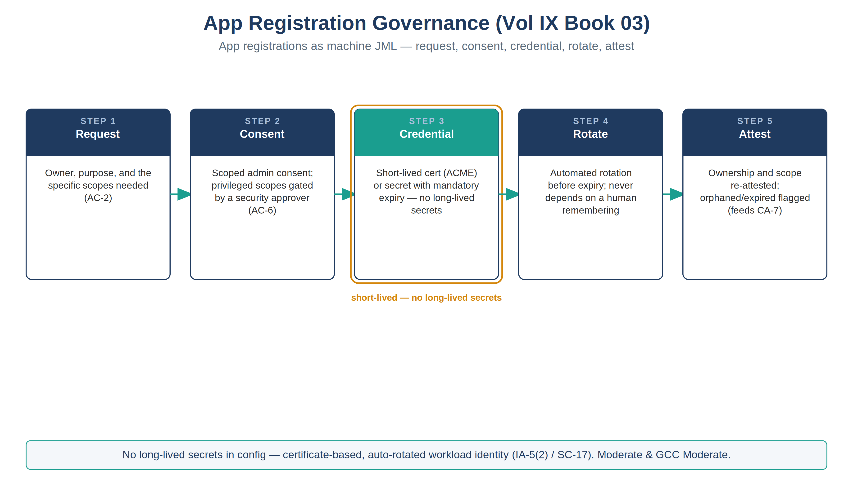
The app-registration lifecycle — request, scoped consent, short-lived credential, automated rotation, attestation
Stage | What happens | Control
1. Request | An app-registration request captures owner, purpose, and the specific scopes needed | AC-2
2. Approve | Any privileged or write scope requires a security approver; least privilege is the default | AC-6
3. Consent | Scoped, admin-consented permissions only — no blanket delegation | AC-6
4. Credential | A short-lived certificate (ACME) or a secret with a mandatory expiry — no long-lived secrets in config | IA-5(2), SC-17
5. Rotate | Automated rotation before expiry; the app never depends on a human remembering | IA-5(2)
6. Attest | Ownership and scope re-attested on a cadence; orphaned or expired registrations flagged | AC-6, CA-7
No long-lived secrets. The single highest-value rule in this book: credentials are short-lived and rotated automatically. A client secret with a two-year expiry sitting in a pipeline variable is the credential an attacker wants most; certificate-based, auto-rotated identity removes the target. This is the IA-5(2) / SC-17 closure, applied to workload identity.

App Registrations Are Machine JML
The lifecycle above is deliberately the same shape as the human joiner/mover/leaver catalog (Book 01): a request with an owner, a governed change of scope, and an evidenced retirement. The leaver step is the one most often skipped for apps — an orphaned service principal with live credentials is exactly the ghost-credential risk that human de-provisioning is meant to close. Attestation (stage 6) is the machine-identity equivalent of an access review.

Closure Necessity

Closure Necessity — a workload identity with no lifecycle is a permanent liability
Volume I/VI prove that certificate-based, short-lived, least-privilege credentials are the mechanism. This book makes the lifecycle of a workload identity governed and evidenced. Without it, app registrations accumulate long-lived secrets and over-broad consent that no scanner authored and no owner reviews — IA-5(2), SC-17, and AC-6 quietly regress with every “temporary” secret that never expires. Governing the lifecycle is what keeps the mechanism true over time.

NIST SP 800-53 Rev 5 Control Closure — Authorities Closed Here
Generated from the compliance spine (aan-compliance-spine.yml); not hand-edited here.
Authorities Closed Here — App Registration Governance (request · consent · secret/cert lifecycle) († = Closure-Necessity anchor: no alternate closure path)
Control | Title | Closing mechanism (function, not product) | Accreditation gate | Authority drivers | Evidence slot | FedRAMP 20x KSI | Tool-attestable?
AC-6 | Least Privilege | Scoped admin consent; over-broad/privileged scopes gated by a security approver; orphaned/expired app registrations flagged for attestation | FedRAMP Moderate | NIST SP 800-53 Rev 5 | Identity | KSI-IAM | No
IA-5(2) | Public Key-Based Authentication | App-registration credentials issued as short-lived certs (ACME) with mandatory expiry and automated rotation — no long-lived secrets in config | FedRAMP Moderate | NIST SP 800-53 Rev 5; EO 14028 | Identity | KSI-IAM | No
SC-17 | Public Key Infrastructure Certificates | Certificate issuance and rotation for service principals via the governed catalog | FedRAMP Moderate | NIST SP 800-53 Rev 5 | Identity | KSI-IAM | No

Honest Limits
- Not every app supports certificate credentials; where a secret is unavoidable, the expiry is short and rotation is still automated — the exception is documented, not silent.
- Consent governance covers new grants; a sweep of existing over-consented apps is a one-time remediation the attestation cadence then maintains.
- Rotation depends on the certificate authority chosen in Vol I Book 03 / Vol VI Book 02; this book governs the workflow, not the CA.

Cross-References
- Vol I Book 03 (Certificates & Tokens) and Vol VI Book 02 (Identity & Access as Code) — the cryptographic-identity architecture this book governs the lifecycle for.
- Vol IX Book 01 — the human JML this app lifecycle mirrors.
- Vol VII Book 04 — where attestation of app-registration ownership/scope lands (CA-7).
- Issue #1140 — the tracking issue for this workstream.

Provenance
Draft. Entra app registrations, ACME, and certificate-based service-principal auth are deployed examples; the request→scoped-consent→short-lived-credential→rotate→attest discipline is the invariant. The figure above is authored as committed house-style SVG per ADR-093, rendered to PNG at 3× for crisp .docx zoom.

